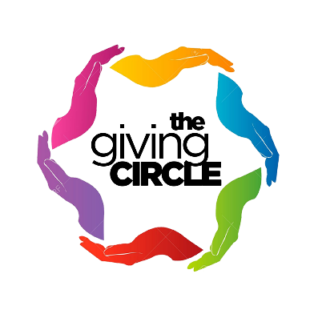

The Giving Circle Scholarship Application

Email the following documents to TheGivingCircleScholarship@gmail.com on or before JULY 15, 2020:

____ Completed Application
____ 800-1000 Word Essay
____ Signed Administrator Form
____ ONE Letter of Academic Reference
____ ONE Letter of Personal Reference
____ Official Acceptance Letter from a College or University

DUE BY JULY 15, 2020
ONE COMPLETE SUBMISSION PER STUDENT.
INCOMPLETE OR DUPLICATE APPLICATIONS WILL NOT BE REVIEWED
OR CONSIDERED FOR AWARD.

Administrator/Counselor/Representative Name:

__________________________________________________________________________________
School/Organization:

_________________________________________________________________________________
School/Organization Address:

_________________________________________________________________________________
Counselor/Representative Email address (ending with .edu):

_________________________________________________________________________________
Applicant Information
Name___________________________________________________________Age________
Mailing Address_______________________________________________________________
City:_______________________________ State:_________ Zip Code:___________________
Student Email Address:_________________________________________________________
Phone number(s):_______________________ (Home)___________________________ (Cell)
School:______________________________________________________________________
Grade Point Average (GPA): _________________
Name of Legal Guardian(s):______________________________________________________
Extracurricular Activities
List any school activities you have participated in or honors/awards you have received during your high school career: ________________________________________________________________________________________________________________________________________________________________________________________________________________________________________________________________________________________________________________________________________
____________________________________________________________________________________________________________________________________________________________________________________________________________________________________________________________________________________________________________________________________________________________________________________________________________________________________________________________________________________________________________
Name___________________________________________________________Age________

List any community activities you have participated in during your high school career:
________________________________________________________________________________________________________________________________________________________________________________________________________________________________________________________________________________________________________________________________________
________________________________________________________________________________________________________________________________________________________________________________________________________________________________________________________________________________________________________________________________________
________________________________________________________________________________________________________________________________________________________________________________________________________________________________________________________________________________________________________________________________________
____________________________________________________________________________________________________________________________________________________________________

Name___________________________________________________________Age________

Short Essay
In 800-1000 words, please address the following:

1. Explain how completing your undergraduate degree can help benefit others.
2. What life events and future aspirations are motivating you to attend college?
3. Write about a time when you were placed in a challenging situation in your life.
What made the situation difficult to manage? How did you overcome the challenge?

YOU MAY DELETE/DISREGARD UNUSED PAGES.

Name___________________________________________________________Age________

Short Essay (Continued)

Name___________________________________________________________Age________

Short Essay (Continued)

Name___________________________________________________________Age________

Short Essay (Continued)

Name___________________________________________________________Age________

Short Essay (Continued)

**************************************ADMINISTRATOR FORM**************************************

The following student is a candidate for The Giving Circle Scholarship:

________________________________________________________

Please complete the following section and provide an official copy of the student’s transcript(s) to the TheGivingCircleScholarship@gmail.com
The above student-applicant:
__ Receives free or reduced lunch (signature from a high school official required if checked)
__ Does not receive free or reduced lunch
Name: _________________________________Phone Number: ________________________
Signature: ____________________________________________Date: ___________________

- END OF APPLICATION -

Thank you for your application!

ALL documentation must be complete and received in one email submission per student BY THE SCHOOL ADMINISTRATOR, SCHOLARSHIP DIRECTOR OR ORGANIZATION REPRESENTATIVE on or before july 15, 2020 thegivingcirclescholarship@gmail.com.

submissions received from students or previously described school officials after july 15, 2020 will not be reviewed or considered for award.

KEEP THIS PAGE FOR YOUR RECORDS!

STUDENT NAME:____________________________________________________

DATE SUBMITTED:________________by:_______________________________

